General Rewards
Merchant Rewards – This is a part of mobile application called MerchantOne.

Create Offers

Offer category - Proposition #1 – General Offer

Business details
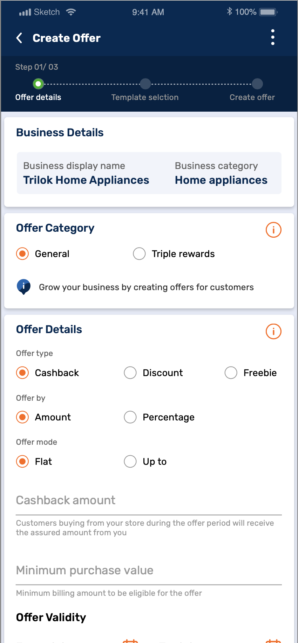
Fields | Variables | DataType | Sample Value | Source DB
Business display name | Short_Name | Character String | Vijay Sales | To be posted in URL
Business category | merchantCategory | Character String | Digital | To be posted in URL
Above mentioned fields will be auto fetched & non-editable.

Step 1: Offer type selection
An offer type to be selected by the dealer. The flow of offer subtype would dynamically change based on selection of the offer. The dealer can select from one of the below 3 offers:
- Cashback: % or Amount cashback on Minimum purchase value (Flat/Up to)
- Discount: Instant discount by percentage or instant flat amount discount on the product
- Freebie: Free gift with the purchase or Buy and Get offer with minimum purchase

Cashback
Merchant has two options of giving Cashback. These are mentioned under the ‘Offer by’ tab.
- By amount: This would allow Merchant to give a pre-decided and fixed amount of cashback after billing of purchased items.( Validation to be same as triple rewards)
- By percentage: This would allow merchant to give a pre-decided and fixed percentage discount on purchase after billing of purchased items. ( Validation to be same as triple rewards)

Cashback by amount
On selecting ‘By Amount’, there will be activation of below input fields
- Offer Mode Selection (Flat / Up to)
  - Flat: A flat cashback amount will be applicable here
  - Up to: A cashback amount up to a certain pre-decided value will be applicable here.
- Input field for cashback value in Rs.
- Input field for Minimum Purchase Value in Rs.

Please see flow as below for Cashback by Amount; Flat
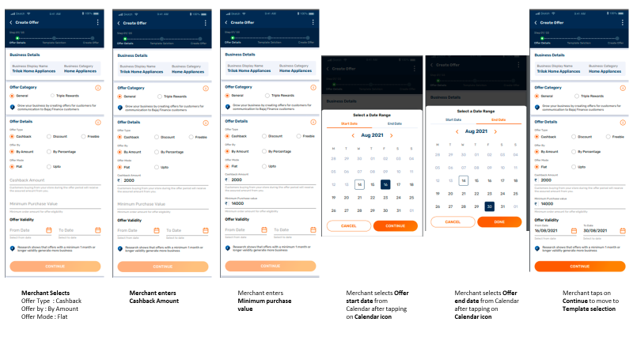

Cashback by percentage
On selecting ‘By Percentage’, there will be activation of below input fields
- Offer Mode Selection (Flat/ Up to)
  - Flat: a flat cashback % will be applicable here
- There will be an additional field activated in case of this selection so that merchant can effectively cap the cashback value to a certain amount.
  - e.g: Get Flat 10% cashback up to Rs.500 on purchase of Home Appliances at Prestige.
  - Up to: A cashback % up to a certain pre-decided value will be applicable here.
- Input field for cashback value in %
- Input field for Minimum Purchase Value in %

Other Scenarios:
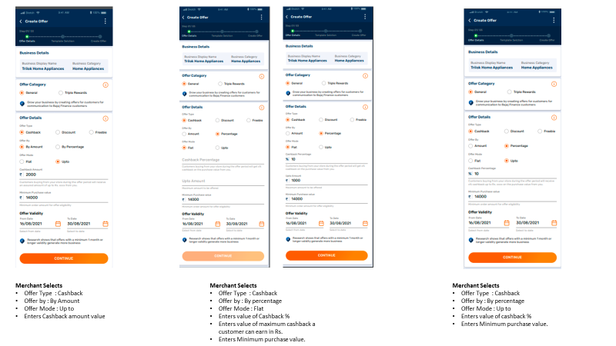

2.2 Discount
Discount Type: Merchant has two options of giving Discount type
These are mentioned under the ‘Offer by’ tab
- By amount: This would allow Merchant to give a pre-decided and fixed amount of discount during billing of purchased items.
- By percentage would allow merchant to give a pre-decided and fixed percentage discount on purchase during billing of purchased items.

Discount by amount
On selecting ‘By Amount’, there will be activation of below input fields
- Offer Mode Selection (Flat/ Up to)
  - Flat: a flat discount amount will be applicable here
  - Up to: A discount amount up to a certain pre-decided value will be applicable here.
- Input field for discount value in Rs.
- Input field for Minimum Purchase Value in Rs.

Please see flow as below for Discount by Amount; Flat
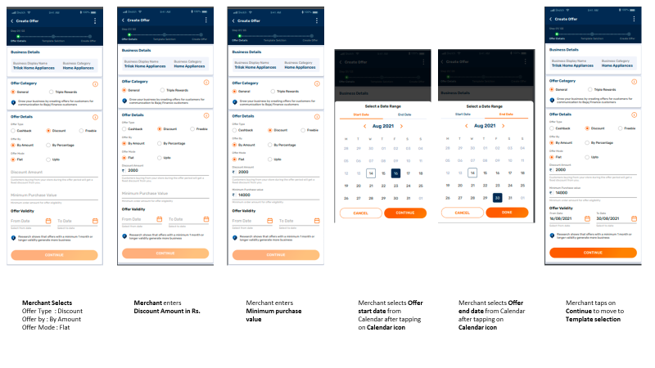

Discount by percentage
On selecting ‘By Percentage’, there will be activation of below input fields
- Offer Mode Selection (Flat/ Up to)
  - Flat: a flat discount % will be applicable here
- There will be an additional field activated in case of this selection so that merchant can effectively cap the discount value to a certain amount.
  - e.g.: Get Flat 10% discount up to Rs.500 on purchase of Home Appliances at Prestige.
  - Up to: A discount % up to a certain pre-decided value will be applicable here.
- Input field for discount value in %
- Input field for Minimum Purchase Value in %
Other Scenarios:
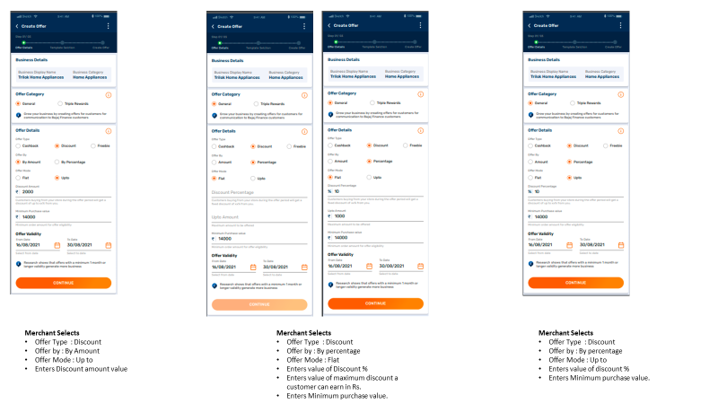

Freebie
There will be two freebies offer type selection via Radio button
- Freebie gift
- Buy & get

Freebie Gift
On selection of freebie gift, fields for entering below details will be activated
  - Freebie product name
  - Minimum Purchase Value
Note: Freebie list to be finalized with the help of business team keeping all product categories under consideration. Master list to be maintained and updated by Business team Spoc.
New additions or removal of items from list to be updated in the Master list by Business Team Spoc
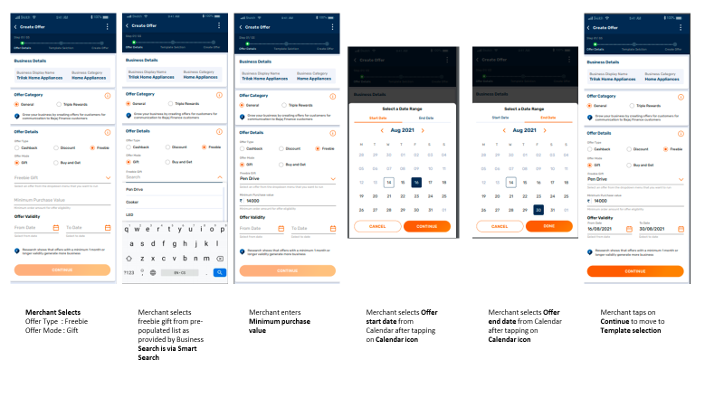

Buy and Get offer
The offer can be customized as per requirement. Merchant can select number of products for fixed purchase and number of products to be given as freebie gift.
The maximum number of products permitted for fixed purchase and to be given as freebie gift is 5.
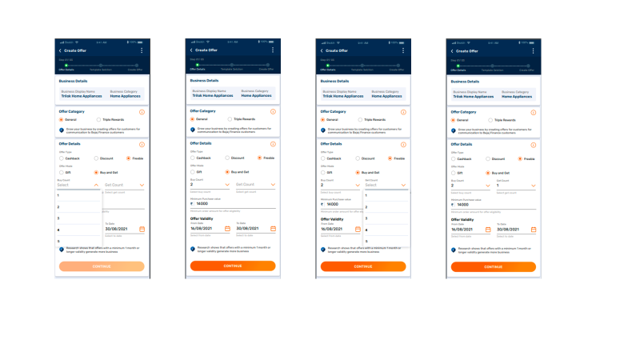

Offer validity
Dealer must select the offer validity. i.e., the start date and end date of the offer from selection calendar field
The following governance rules would be hard coded and applied in this stage:

- Offer validity start date > current date
  - The offer should be valid from a date after the current date.
  - Offer start date should bare minimum be 2 days from that of current date i.e., if merchant is creating an offer on 21st July 2021, the offer start date can be no earlier than 24th July 2021. Therefore, dates before 24th i.e., 22nd and 23rd July 2021 must be not selectable for Merchant.
  - The execution date threshold however must be flexible for change.
- System date and offer date comparison
The system should compare the system date and offer start date. If the offer start date is greater than system date, the offer should go in queue and should not be executed. If offer start date is equal to system date, the offer should be executed (All offers should be executed on offer start date).
  - In case of general offers, execution time will be 48hrs.
  - In case of Triple Reward, offers execution time will be 24hrs.
- If the offer start date is greater than system date, the offer should go in queue and should not be executed. If offer start date is equal to system date, the offer should be executed (All offers should be executed on offer start date).
- Start date preceding system date for Selection for Offer
Date preceding to system date should not be available for selection while selecting offer validity from date
- Parallel Offers
No more than one offer/campaign can run at a time for one specific dealer
- Offer can be created maximum 60 days in advance from the current system date.

Step 2: Template selection
Under template Selection, merchant will be able to select the message template type based on occasion for uploading the offer. Based on template selected, the message would be composed
- Regular
- Festive

Language
Merchant will be able to select the language through which communication needs to be sent to customers. The default option here is English.
An additional option of the local language (based on Pin-code/state-wise languages available at master’s with BFL) will be induced in Phase 2
Dealer must select the language in which he wants to execute the communication to his customer base.
The message templates in different languages should be stored in the system. There are options of 10 languages available
Also, these language master to carry a flat of template available, only if the template for a specific language is available then the flag for template available should be yes and then only language should reflect.

English (Phase 1)

Bitly
A bitly should be generated for every offer. On clicking the bitly, Dealer chatbot will open this will be pulled from the Offer QR of that Merchant in User Profile Tab and the same is also hosted in Galaxie Portal.
This will be available to view at the time of template selection

#1 - Regular Offer Journey
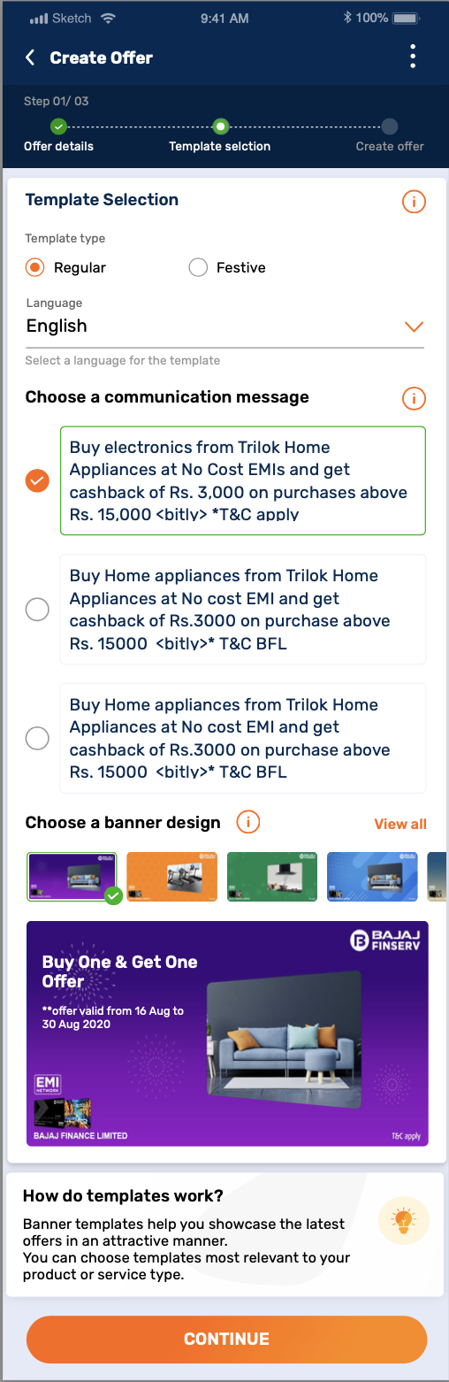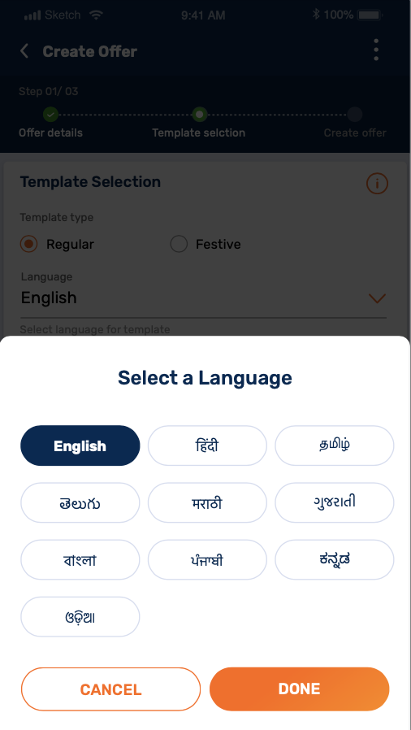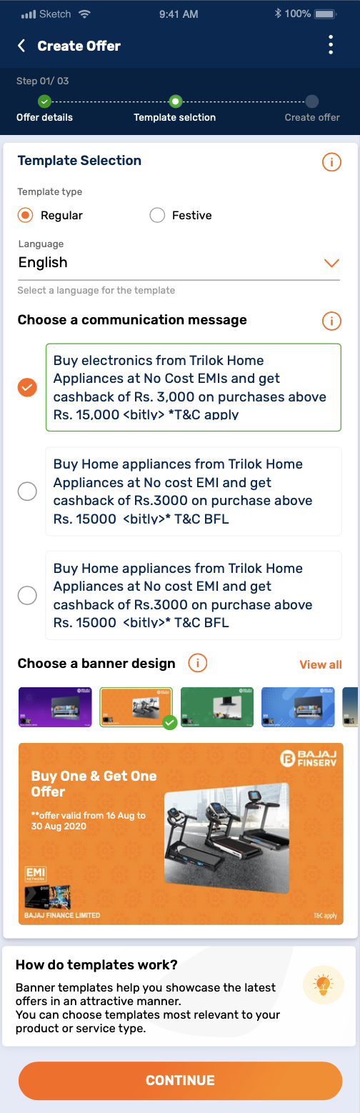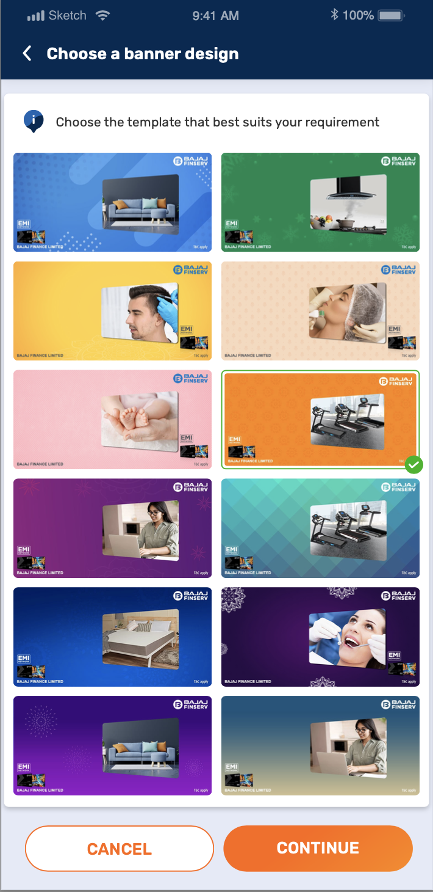
Screen #1: Template type “Regular”
Screen #2: Select Language. “English” will be selected by default. Need not plot this section only if English language is available.
Screen #3: Choose a communication message. Merchant selects from pre-populated message templates.
Screen #4: Merchant selects a banner option from the provided creatives. Tap on select.

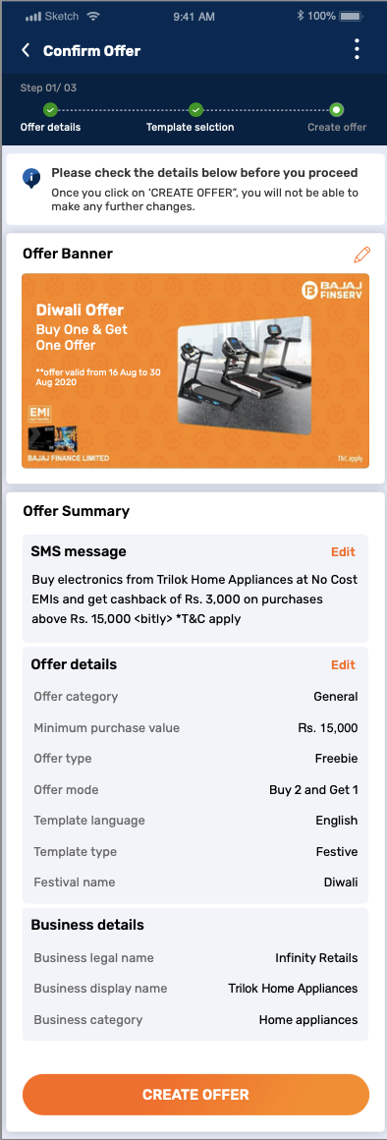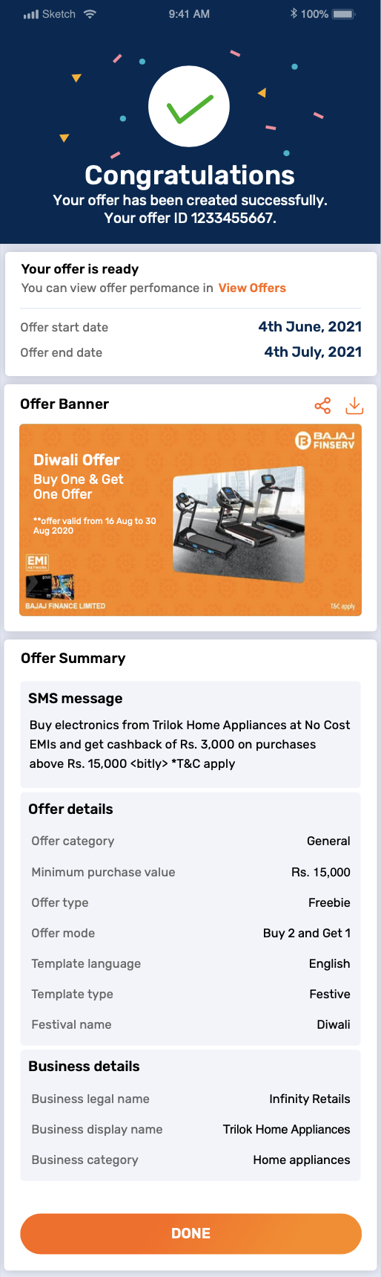
Screen #5: Merchant previews the offer before final submission. In case specific details are to be edited by the merchant, option to do the same is provided on “SMS Message” & “Offer Details” cards. → Content to be updated. Too much of “Offer”
Screen #6: Final confirmation of offer creation is displayed to the merchant. Option to directly “View offer” is provided → Seems insignificant here & copy on SMS text

Event Selection
This field is required only if the dealer has selected a festive template. If dealer has selected a general template, this field should be hidden? The option of events available for a dealer to select will depend on the language selected by him (To incorporate region specific festivals). Following table captures the event available to the dealer
The events that are available for selection to merchant would be visible as per the range of month, i.e., the events for the current month and next 60 days should be visible.
The below master will be configurable in terms of first-time setup of master of all events and then YOY maintenance of dates for the new calendar year.(attached list)
Event | Date
New Year | 1st Jan 2021
Republic Day | 26th Jan 2021
Holi | 29th March 2021
Ganesh Chaturthi | 10th Sept 2021
Dhanteras | 2nd Nov 2021
Diwali | 4th Nov 2021
Christmas | 25th Dec 2021
Gudi Padwa | 13th April 2021
Navratri | 7th-15th Oct 2021
Pongal | 14th Jan 2021
Makar Sankranti | 14th Jan 2021
Ugadi | 13th April 2021
Durga Puja | 11th-15th Oct 2021
Lakshmi Puja | 4th Nov 2021
Poila Boishakh | 15th April 2021
Baishakhi | 13th April 2021
Onam | 12th-23rd Aug 2021
Valentine’s Day | 14th Feb 2021
International Women’s Day | 8th March 2021
Summer Sale | 1st March 2021 - 31st May 2021
Winter Sale | 1st Dec 2021 - 31st Jan 2021
Monsoon Sale | 1st June 2021 - 30th September
EOSS | Ask Jerin (REMI)
Independence Day | 15th August 2021
Check excel –
Note: ARU team should maintain the festival and language master, add more festivals and different languages to the list in the back end, and they should be visible to the dealer, once successfully added.

Choose your communication message
Under ‘Choose communication message’, there will be list of three pre-populated communication templates. Merchant must select the one that best communicates Merchant’s offer details.

Choose banner design
Multiple templates should be available. These banners would flow to a bitly link and would be populated with dealer name. These bitly would be circulated along with SMS to the dealer. Once the customer clicks on the bitly, he would be able to view the static banner along with the dealer’s name. the dealer should be able to select any template that he wishes to display to customers as a part of the bot. Bitly will be redirect user to 3-in-1

Message and banner preview
Based on the following parameters selected by the dealer, a static message to be created
- Template type (Generic / Festive)
- Festival type (If template type selected is festive)
- Language
- Supplier Category
- Offer type: Cashback/Discount/Freebie
- Offer subtype (Amount/Percentage/Freebie type)
- Offer Mode (Flat/Up to)
- Maximum Cashback/Discount Amount (in case of flat % cashback/discount)
The dealer’s name in the message template should be picked from the dealer login credentials
Message templates for Cashback, Discount and Freebie in English are as follows:
Offer Type | Offer Sub Type | Offer Mode | Up to Value | Event Type | Template 2
Cashback | By Amount | Flat | - | Festive | This {Festival Name}, buy {Supplier Category} from {Dealer Name} and get {Offer mode} Rs {Cashback Amount} {Offer Type}. <bitly> T&C BFL
Cashback | By Amount | up to | - | Festive | This {Festival Name}, buy {Supplier Category} from {Dealer Name} and get {Offer mode} Rs {Cashback Amount} {Offer Type}. <bitly> T&C BFL
Cashback | By Percentage | Flat | up to | Festive | This {Festival Name}, buy {Supplier Category} from {Dealer Name} and get {Offer mode} {Cashback % value}% {Offer Type} up to Rs.{Up to value}. <bitly> T&C BFL
Cashback | By Percentage | up to | - | Festive | This {Festival Name}, buy {Supplier Category} from {Dealer Name} and get {Offer mode} {Cashback % value} {Offer Type}. <bitly> T&C BFL
Cashback | By Amount | Flat | - | Generic | Enjoy {Offer mode} Rs.{cashback amount} {Offer Type} on {Supplier category} at {Dealer Name}. <bitly> T&C BFL
Cashback | By Amount | Up to | - | Generic | Enjoy {Offer mode} Rs.{cashback amount} {Offer Type} on {Supplier category} at {Dealer Name}. <bitly> T&C BFL
Cashback | By Percentage | Flat | Up to | Generic | Enjoy {Offer mode} {cashback % value}%{Offer Type} up to Rs.{Up to value) on {Supplier category} at {Dealer Name}. <bitly> T&C BFL
Cashback | By Percentage | Up to | - | Generic | Enjoy {Offer mode} {cashback % value} {Offer Type} on {Supplier category} at {Dealer Name}. <bitly> T&C BFL
Discount | By Amount | Flat | - | Festive | This {Festival Name}, buy {Supplier Category} from {Dealer Name} and get {Offer mode} Rs {Discount Amount} {Offer Type}. <bitly> T&C BFL
Discount | By Amount | Up to | - | Festive | This {Festival Name}, buy {Supplier Category} from {Dealer Name} and get {Offer mode} Rs {Discount Amount} {Offer Type}. <bitly> T&C BFL
Discount | By Percentage | Flat | Up to | Festive | This {Festival Name}, buy {Supplier Category} from {Dealer Name} and get {Offer mode} {Discount % value}% {Offer Type} up to Rs.{Up to value}. <bitly> T&C BFL
Discount | By Percentage | Up to | - | Festive | This {Festival Name}, buy {Supplier Category} from {Dealer Name} and get {Offer mode} {Discount % value} {Offer Type}. <bitly> T&C BFL
Discount | By Amount | Flat | - | Generic | Enjoy {Offer mode} Rs.{Discount amount} {Offer Type} on {Supplier category} at {Dealer Name}. <bitly> T&C BFL
Discount | By Amount | Up to | - | Generic | Enjoy {Offer mode} Rs.{Discount amount} {Offer Type} on {Supplier category} at {Dealer Name}. <bitly> T&C BFL
Discount | By Percentage | Flat | Up to | Generic | Enjoy {Offer mode} {Discount % value}%{Offer Type} up to Rs.{Up to value) on {Supplier category} at {Dealer Name}. <bitly> T&C BFL
Discount | By Percentage | Up to | - | Generic | Enjoy {Offer mode} {Discount % value} {Offer Type} on {Supplier category} at {Dealer Name}. <bitly> T&C BFL
Freebie | - | Freebie Gift | - | Festive | This {Festival Name}, buy {Supplier Category} from {Dealer Name} and get a {Freebie Type} free . <bitly> T&C
Freebie | - | Freebie Gift | - | Generic | Avail a free {Freebie Type} on purchase of {Supplier category} at {Dealer Name}. <bitly> T&C BFL
Freebie | - | Buy and Get | - | Festive | This {Festival Name}, buy <buy count> and get <get count> on purchase of {Supplier Category} from {Dealer Name} <bitly> T&C
Freebie | - | Buy and Get | - | Generic | Avail {Freebie Type} worth Rs {Freebie Worth Amount} on purchase of {Supplier category} at {Dealer Name}. <bitly> T&C BFL

#2 - Festival Offer Journey
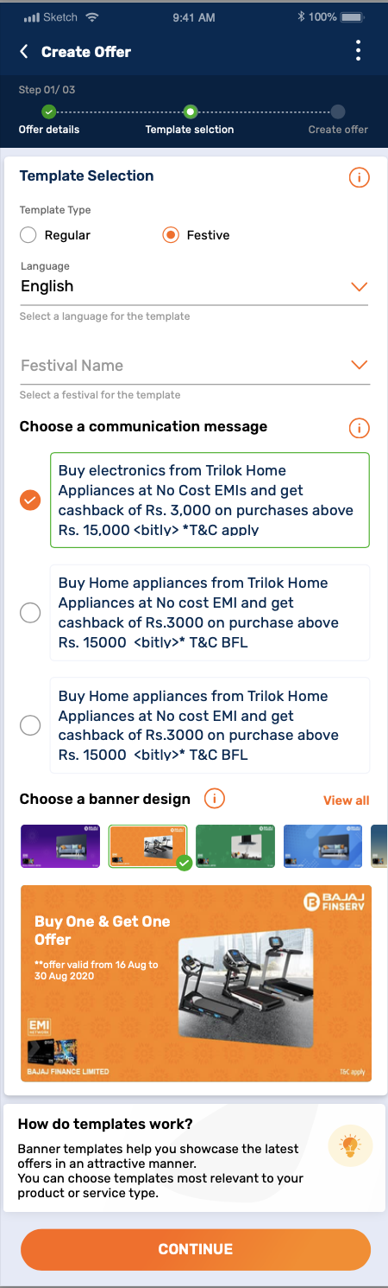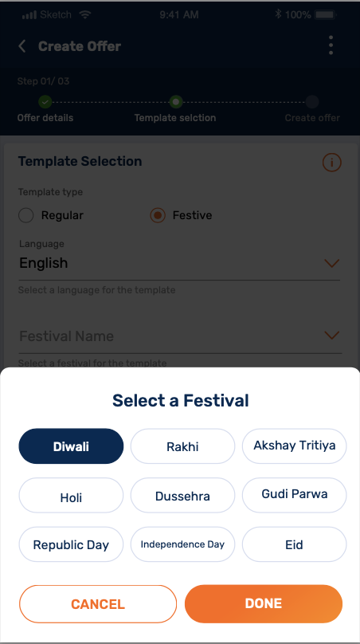
Note: Only “Festival name” field will be an addition which will display a dump of festivals available in the master. Rest flow will remain same as Regular offer flow.

Step 3: Submit & approval
- Pre-confirmation screen will be displayed to the merchant where the overview of created offer will be available. Merchant can choose to edit the details if required.
- Merchant needs to accept the Terms & conditions i.e., in case of any disputes raised by the customer regarding triple reward offer, merchant needs to honor the reward details & BFL will have no liability towards it. → Yet to be added. Discussed with the team.
- On selecting edit, merchant will be taken to the respective screen page for editing

Relationship level access
Both parent and child dealer counters can run their own offer in General Offer Propagation
CRATE A STORED PROCEDURE - usp_GeneralReward_Insert_OfferDetails
Which will accept the user inputs from above application and insert data into backend table – GeneralAndTripleReward_OfferDetails.
Below are the validations and requirements –
- OfferCategory should be valid (Active from GeneralReward_OfferCategoryMaster)
- OfferType should be valid (Active from GeneralReward_OfferTypeMaster)
- OfferMode should be valid (Active from GeneralReward_OfferModeMaster)
- Validate MerchantId, SourceUniqueId is valid (GeneralReward_MerchantData)
- Offer Start Date should be in future (It should not be less that or equal to current date).
- One merchant can have only one offer created for a data range (No overlapping offers)
- OfferId should be generated for each new offer inserted with following format –
OFF-YYYYMMDD000001. Example OFF-20260729000001, OFF-20260729000002 etc
- Display error messages in case any validation fails.
- Capture logs (Errors/Steps into audit table - GeneralReward_adtSQLAuditLog
- Generated OfferId should be disaplyed as output with message as “XXXXX - offer created successfully”

